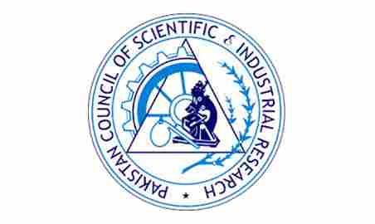
HANDS ON TRAINING
GAS CHROMATOGRAPHY-MASS SPECTROMETRY (GCMS- QP2020 NX)

Organized By
Natural Products & Herbal Development Section
Pharmaceutical Research Center
PCSIR Laboratories Complex, Karachi
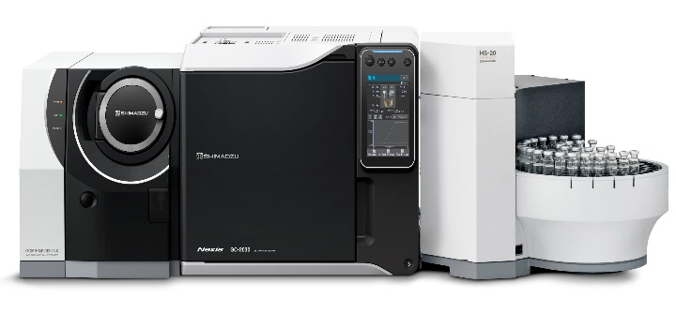  You Will Learn  - Tuning and Calibration, Calibration report generation, MS Tune File, Explanation of MS Method and GC Method.  - System and method Parameter setup, Set up method for Full Scan and Single Ion Monitoring Operation, On-column injection, Split/Split less injection.  - Library search Concepts, integration, report generation.  - Sample preparation techniques/ Extraction techniques with an interactive demonstration.  - Maintaining the GC-MS instrument and troubleshooting the problems related to gas supply, inlet, auto-sampler, column and detector. | This training program is onlyfor the professionals and students seeking for GC-MS training. We offer hands-on practice on GC-MS with Head Space (HS). The training is conducted in accordance with the specified procedures and fundamental principles of GC. The Theory of Single/Triple Quadrupole, Data quantification and Data acquisition, General Software and Hardware, System Evaluation and Method building all are explained in detail.  Advantages  GC-MS finds application in fields like Medicine, criminal forensics, environmental monitoring and cleaning, explosives detection, etc. Thus the training is beneficial for the people who are willing to enter the industries which relates to chemicals, pharmaceuticals, food, oils, agriculture, cosmetics, analytical testing laboratories and many others.

Contact Information:
Dr. Shazia Yasmeen, PSO  Cell No. 03394007618; Email: shazrasheed@yahoo.com | Dr. Ghulam Fareed, SSO  Cell No. 03002522698; Email: fareedchm@yahoo.com
PROGRAMME FOR THREE DAYS HANDS ON TRAINING ON
GAS CHROMATOGRAPHY-MASS SPECTROMETRY (GCMS- QP2020 NX)

Day-1: 15.04.2025; Tuesday
09:30-09:40 | Recitation of Holy Quran
09:40-09:50 | Welcome Note by Director General
09:50-10:05 | Introduction of Pharmaceutical Research Centre, by Dr. Rashid Ali Khan, CSO/ Head of Centre
10:05-10:10 | Introduction of Participants
10:15-10:40 | Role and use of gas chromatographic technique in industry by Dr. Shazia Yasmeen, PSO/PRC
10:40-11:15 | Basic understanding and fundamentals of GCMSby Dr. Hamna Rafiq, RO
11:15-11:30 | Tea Break
11:30-13:00 | Detailed overview about instrumentation including Head Space and software operation by Dr. Ghulam Fareed, SSO
13:00-14:00 | Prayer and Lunch
14:00-15:00 | Column selection and installation

Day 2: 16.04.2025; Wednesday
09:30-10:30 | Sample preparation techniques
10:30-11:15 | Sample Derivatization Techniques
11:15-11:30 | Tea Break
11:30-13:00 | Pre-Acquisition software operation, tuning and calibration, sample acquisition in single mode and batch mode, qualitative and quantitative Analysis, SIM and Scan Mode
13:00-14:00 | Prayer and Lunch
14:00-15:00 | Basic understanding of head space and conversion of liquid injection mode to head Space

Day 3: 17.04.2025; Thursday
09:30-10:30 | Sample Preparation for head space
10:30-10:45 | Running of Samples for head space
10:45:11:15 | Results Interpretation and library search results analysis
11:15-11:30 | Tea Break
11:30-12:00 | Question answers
12:00-12:30 | Closing ceremony & certificate distribution
____________________________________________________________________

